**Comparison of TN and IPS Panels for Use in MishCo All-In-One Computers**

**Introduction:**

Over the past five years, often with help from customer feedback, we have developed cases that are more robust, upgraded our processors, and added dedicated graphics to our all-in-ones. With the most recent round of customer feedback reviewed, we have identified one major theme: our screens. While there are a plethora of different panels available, this report will only consider TN versus IPS panels. TN and IPS have the largest share in the market and seem the most usable. Another thing to note: we currently use TN panels in our all-in-ones. With TN panel’s excellent response times and lower cost and IPS panel’s superior color quality and viewing angles, each monitor type seems to fill its own, independent niche. It is my recommendation that we, as a quality, consumer-focused company, adopt both panels, allowing users to choose which one they want in accordance with their preferences. Gamers and those on a budget will thank us for the quick responding, low cost TN panels, while photo/video editors and photographers will relish over the superior color quality of the IPS panels.

**TN vs IPS:**

***- Colors***

Of the two types being compared, IPS monitors are far superior to TN monitors in the color category. TN monitors only use six bits to represent their colors, whereas IPS panels use eight. This means that TN panels can only emit a quarter of the unique colors that an IPS panel can. Looking at Figure 1 to the right, notice how much more vibrant the fish’s face is in the IPS display than in the TN display. Additionally, the sea-life around the clownfish is much more vibrant and multi-hued in the IPS panel. IPS panels (and the colors they can produce) are necessary for photo and video editors who value color fidelity and accuracy immensely in their work. While we have no direct data, by looking at user reviews we can conclude that many different groups buy our all-in-ones. We have the general users, gamers, and photo/video editors.   
While we do not currently have plans for touch screen computers, the possibility remains and it must be considered. Looking at touch screens, the IPS is once again superior to TN panels. When you apply pressure to a TN panel (from a finger touching it, for example) the colors underneath temporarily wash out. This leaves unsightly trails behind your finger (see Figure 2, above). IPS panels, on the other hand, do not have this issue.

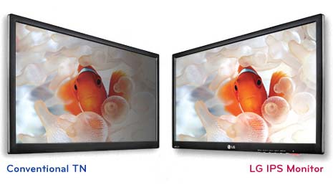**Figure 1: TN vs IPS color comparison**

***- Responsiveness***

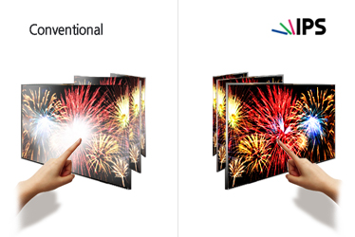 **Figure 2: TN touchscreen color distortion vs IPS clarity**

Perhaps the second most important factor in a screen is responsiveness. Responsiveness, in LCD-panel terms, is defined by how quickly individual LCD-pixel can change colors, specifically how quickly they can go from light to dark and back (gray-to-gray, GTG). TN panels are the clear winner of this category, with average GTG times of 2-5 milliseconds. IPS panels average 6-16 milliseconds. While these differences may seem insignificant, they are not. Even with such small differences, ghosting is much more prevalent with higher GTG times. In ghosting, since the pixels cannot change fast enough, moving objects on screen create phantom copies and blurs in their motion trails. Looking at figure 3, above, you can see the TN panel only has one “ghost” of the moving car, while the IPS panel on the right has two “ghosts”. Ghosting is important to everyone as both sports and movies benefit from crisp motion, but is especially important for gamers, whose high-paced games require the sharpest motion representation. While average TN panels have these low GTG times, to get an IPS panel with a 1 or even 2 millisecond response time, you need to pay double or triple, which would cost our customers.

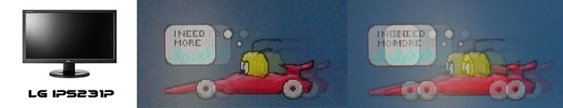  
**Figure 3: Low ghosting in a TN panel (left) vs a slower IPS panel (right)**

***- Viewing Angles***

When it comes to viewing angles, IPS panels are the clear winners. Due to the differing constructions of TN and IPS panels (see figure 4, left) TN panels need to be looked (near) head on. The liquid crystal units are not held in place parallel to the plane of the screen, so when the user looks at it from a skewed angle, the units do not form the same picture. In an IPS panel, the electric field maintains the units parallel to the plane of the screen so the picture is more similar along a wider range of angles. The more angled a TN panel is, the more the colors and brightness shift away from the original. While not perfect, IPS panels do a much better job of maintaining color and brightness fidelity at non-direct viewing angles (see figure 5, right). All the IPS panels on the left have similar brightness and very little color distortion, while the TN panels on the right differ strongly from the ideal, middle panel.

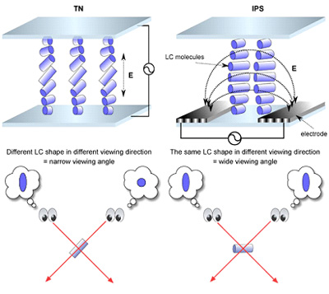**Figure 4: TN vs IPS construction and viewing angles**

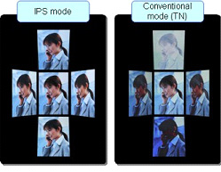 **Figure 5: Example of viewing angle importance**

***- Cost***

While it is true that IPS panels are more expensive than TN panels, as a company that makes around $75 million gross per year, it is well within our budget to spend a little more to buy more expensive IPS panels. As the panels themselves are pre-assembled, all we would need to do is create a separate storage area for them: there is no difference in the installation process between TN and IPS panels. At the end of the day, our costs shift to users who purchase our products. With each monitor type having clear niche appeal, I feel it is unfair to impose a price increase on every user if we switch to IPS panels. At the same time, we strive to bring quality products to our consumers, and if they want superior colors it does not seem fair to shortchange them with TN panels.

**Conclusion:**

Fundamentally, we are a quality-focused company that caters to the needs of our customers. Why should we then force all of our customers to have one type of panel? With each panel having different strengths and weaknesses, they fall, almost perfectly, into separate niches. The lower cost and quick response times of TN panels appeals to gamers and general-purpose users, while the unparallel color fidelity of IPS panels appeals to video/photo editors and photographers. Our company sells computers to all of these people, so why not let each individual choose what they need from their screens? User customization allows us to cater precisely to our users’ needs, allowing us to bring a higher quality product to more people.

Works Cited:

GLOSSARY: IPS. (n.d.). Retrieved March 13, 2016, from http://www.prad.de/en/monitore/shownews_lex7025.html

High Picture Quality. (n.d.). Retrieved March 13, 2016, from   
http://www.j-display.com/english/technology/jdilcd/pictureq.html

IPS. (2014). Retrieved March 13, 2016, from http://www.lgdisplay.com/eng/product/technology/IPS

Ivankov, A. (2015, October 01). Advantages and Disadvantages of IPS Screen Technology. Retrieved March 13, 2016, from   
http://www.versiondaily.com/advantages-and-disadvantages-of-ips-screen-technology/

Jirsa, P. (2012, December 14). What is an IPS Monitor? A Practical Guide to Understanding Display Technology. Retrieved March 13, 2016, from   
https://www.slrlounge.com/what-is-an-ips-monitor-understanding-ips-displays/

LCD Panel Technology: IPS, VA, PLS, AHVA & TN Monitors. (n.d.). Retrieved March 13, 2016, from http://www.pchardwarehelp.com/guides/lcd-panel-types.php

TN Vs. IPS Vs. VA. (2011). Retrieved March 13, 2016, from   
http://www.tnpanel.com/tn-vs-ips-va/

Company Description:

MishCo is a modestly sized (~$75 million gross a year) company that has managed to work its way into the all-in-one computer market (screen and computer in one sleek unit). The company believes in catering to its customers and takes feedback seriously. Over its five year lifespan, MishCo has steadily been upgrading the quality and specifications of their all-in-ones, partly in direct response to user feedback and partly due to an underlying philosophy of delivering quality products to consumers.